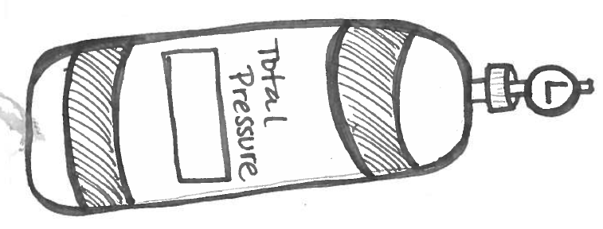
Add up all of your answers, ask your teacher to check the final answer.
P_{T}= 760mmHg + 34mmHg + 1000mmHg

P_{T}= 8.39 atm + 23.43 atm + 12 atm + 3 atm

920 kPa= 89 kPa + 99 kPa+ 350 kPa + P₄

5323mmHg= 1984 mmHg+ 1977mmHg+ P₃

P_{T} | P₂ | P₂ | P₃ | P₄
3029kPa | 323kPa | 1939kPa | 745kPa
 | 7atm | 2.3 atm | 10 atm | .48atm

I have a flask with three gases inside: oxygen, nitrogen, and helium. The oxygen has a partial pressure of 0.23 atm, while the nitrogen exerts a pressure of 0.64 atm, and the helium exerts 0.09 atm of pressure. What is the total pressure in the flask?

A basketball is pumped with air. The total pressure of the ball is 8.2 kPa. I know that several gases are in the ball. Oxygen exerts 2.15 kPa, nitrogen exerts 4.34 kPa, and hydrogen exerts 0.78 kPa. If the other gas in the ball is helium, how much pressure does the helium exert?

